USE CASE DIAGRAM AND USE CASE DESCRIPTION OF

NAME- Gursewak singh

STUDENT ID - 100383511

TEAM MEMBER GIT HUB URL - https://github.com/Navjot1428/USECASE.git

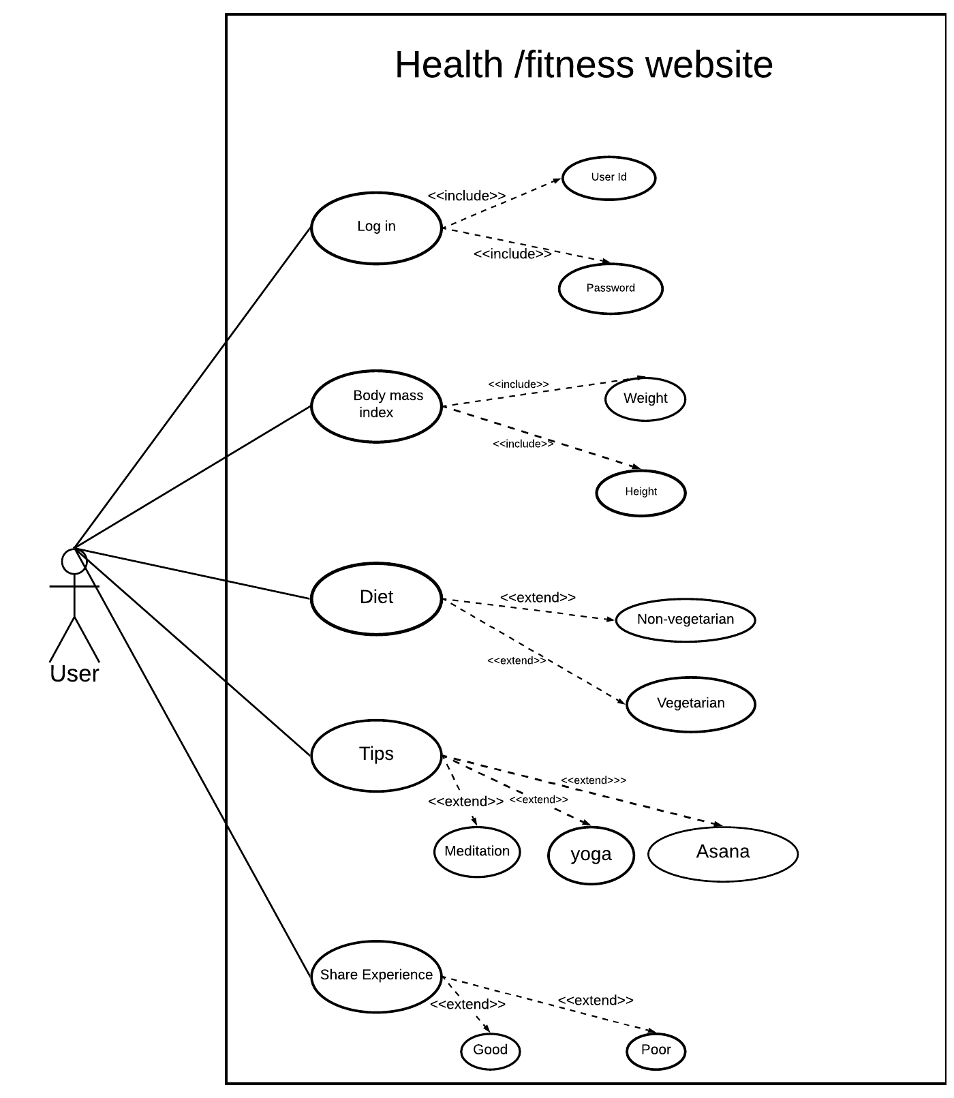

|  |
| --- |
| Use case title: Body mask index |
| Goal: To get the perfect health it is important know weather the user have to gain weight or loose weight. |
| Primary Actor: Anyone logged in to website & who want the healthy lifestyle can be a user. |
| Level: kite level |
| Preconditions: Height and weight must be entered. |
| Minimal Guarantee: The user may get the wrong body mass index as the values entered keeps changing. |
| Success Guarantee: The user will get the approximate body mass index of the body if the user enters height and weight. |
| Main success scenario:   1. User will get the body mass index when the user enters the weight and height in website. |
| Extensions:  2a.The Body mass index is inaccurate.  2a1. Height entered is inaccurate (e.g: The height is 49.9cm but the user enter the 49cm)  2b1. Weight entered is inaccurate (e.g: The weight is 50.8kg but the user entered 50kg ) |

**Use case diagram and use case description of my team member**

**Team member name – Navjot kaur**

**STUDENT ID – 100385217**

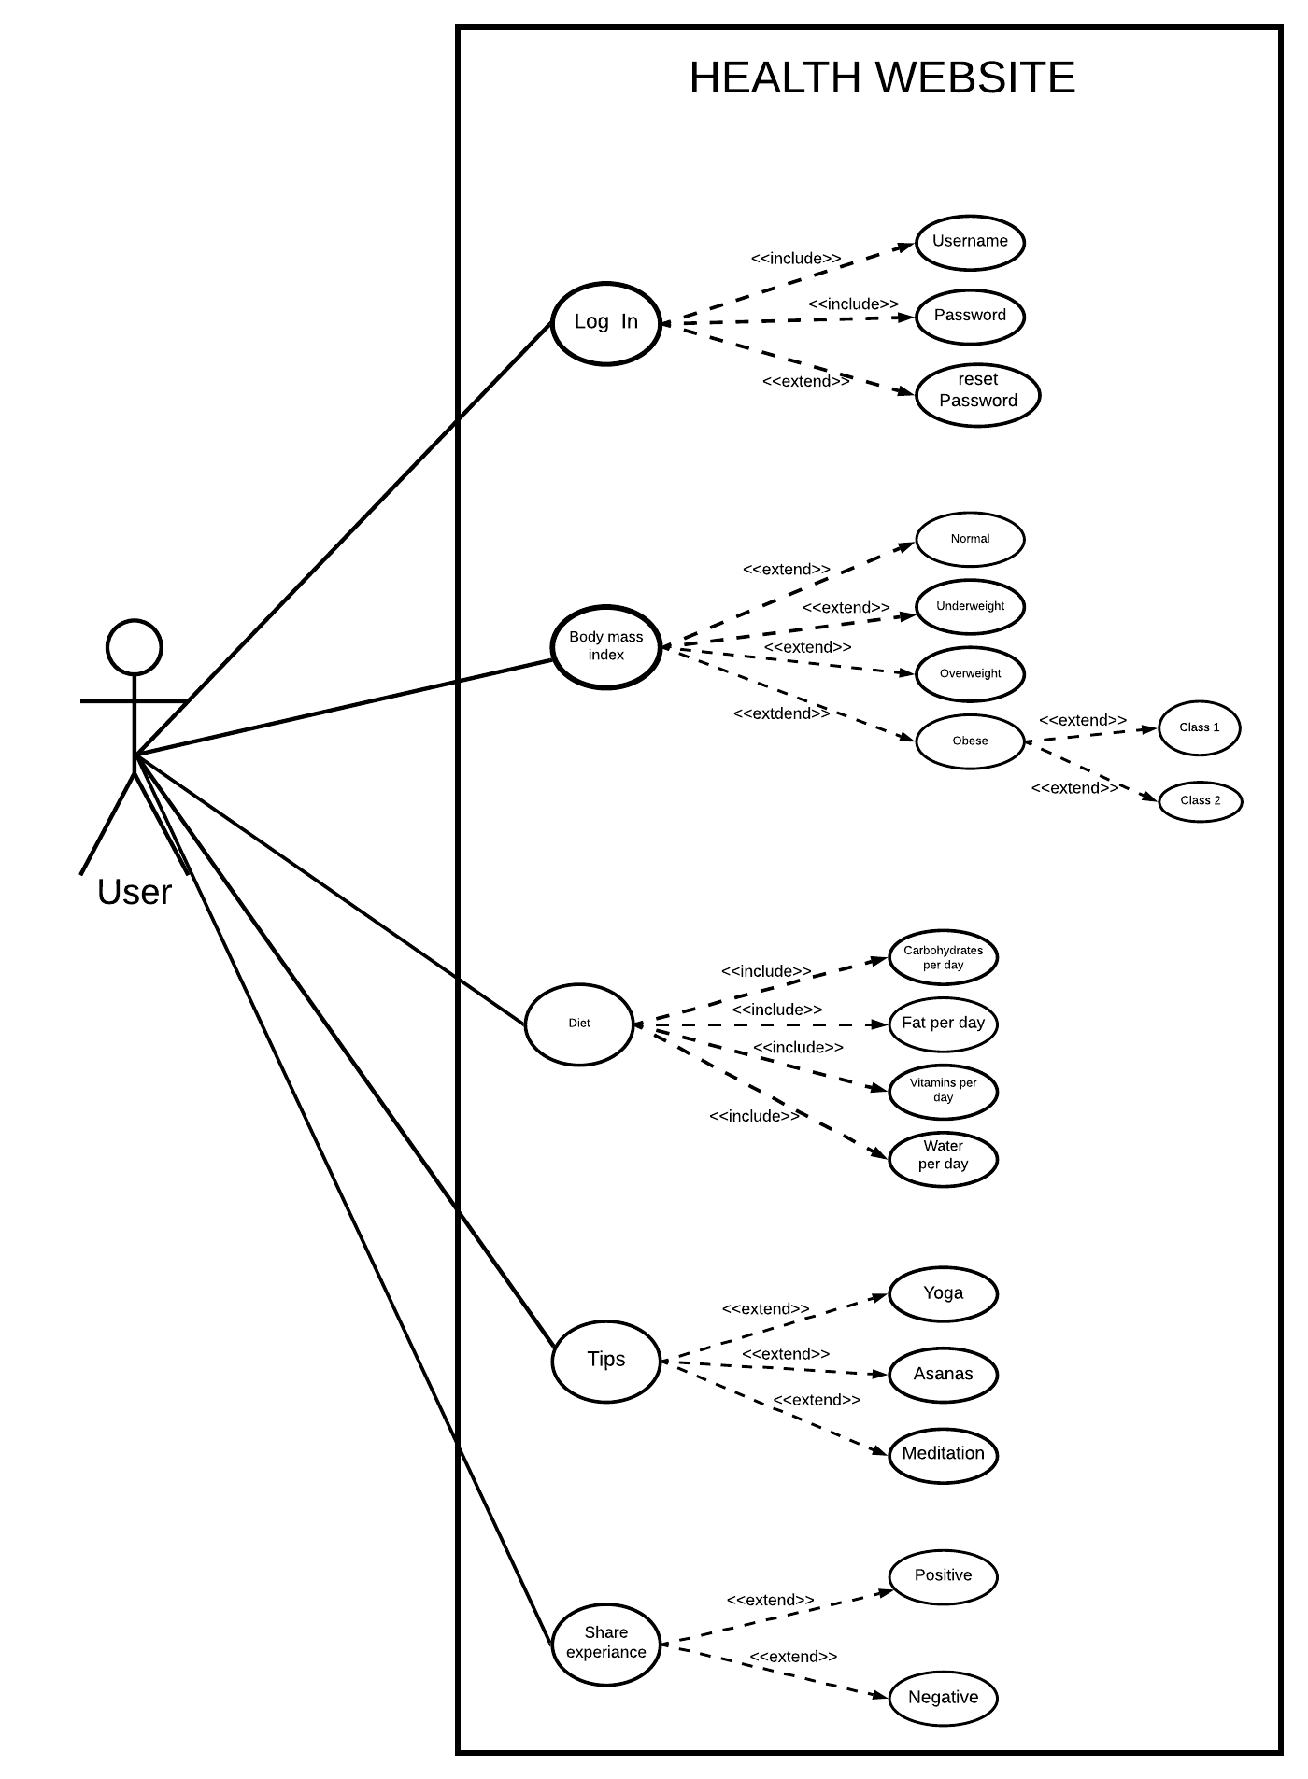

|  |
| --- |
| Use case title: Tips |
| Primary Actor: Anyone with the internet connection and logged in to website can be a user. |
| Goal: To do the exercises in correct position in order to gain weight or loose weight. |
| Level: kite level |
| Preconditions: User have to perform all the exercises very carefully. |
| Minimal Guarantee: If proper instruction is followed for at least 2 weeks more then 40% result will be seen. |
| Success Guarantee: There will be some change in mental health as well as physical health. |
| Main success scenario:   1. User selects the exercise according to level of fitness that will help to improve health |
| Extensions:  4a User performs the exercises in incorrect position.   1. Pain while doing Exercises.   4a1. The user did the exercises not as per the website tips and it results in some kind of pain.   1. It stops paining when the user corrects the posture. |

REVIEW

REVIEW OF USE CASE DIAGRAM AND DESCRIPTION

DIAGRAM ORIGINATOR = NAVJOT KAUR

REVIEWER NAME= GURSEWAK SINGH

USE CASE DIAGRAM



USE CASE DIAGRAM REVIEW:

***To Log In*** the user will type the username and password for the website but in some situations if the user forgets the password the user can reset it using the reset password.The user have to choose from the options what type of ***Body mass index*** he/she have (Normal , Underweight ,Overweight ,Obese). Some of these is further divided into classes to get accurate knowledge about weather the have to gain weight or loose weight. When user click on **Diet** there is approximate quantity which the user have to take everyday to improve the health in given time.

Three different types of exercises(yoga, asanas , meditation) are available from which the user can select any one to improve the health and for the selected exercise **Tips** will be displayed on the screen. **Sharing experience -**  User will share the experience so the Other users can get aware about website ratings and also get the desired health they want.

REVIEW ON USECASE DESCRIPTION

DESCRIPTION ORIGINATOR = NAVJOT KAUR

REVIEWER NAME= GURSEWAK SINGH

|  |
| --- |
| Use case title: Tips |
| Primary Actor: Anyone with the internet connection and logged in to website can be a user. |
| Goal: To do the exercises in correct position in order to gain weight or loose weight. |
| Level: kite level |
| Preconditions: User have to perform all the exercises very carefully. |
| Minimal Guarantee: If proper instruction is followed for at least 2 weeks more then 40% result will be seen. |
| Success Guarantee: There will be some change in mental health as well as physical health. |
| Main success scenario:   1. User selects the exercise according to level of fitness that will help to improve health |
| Extensions:  4a User performs the exercises in incorrect position.   1. Pain while doing Exercises.   4a1. The user did the exercises not as per the website tips and it results in some kind of pain.   1. It stops paining when the user corrects the posture. |

As the **Use case title** illustrates this is the use case description on tips in which the **Primary Actor** could be anyone with the internet access and logged in to website can be a user. . Moving ahead the **Goal** is to do the exercises in correct position in order to gain weight or loose weight.. This use case description is on the Kite **level** and the only **Precondition** is that the user have to perform all the exercises very carefully. The **Minimal Guarantee** that if proper instruction is followed for at least 2 weeks more then 40% result will be seen and the **Success Guarantee** is that there will be some change in mental health as well as physical health.

However **Main success scenario** is that the User selects the exercise according to level of fitness that will help to improve health **Extensions** is that if the User performs exercises in incorrect position he or she will feel Pain while doing Exercises and the reason behind this could be The user did the exercises not as per the website tips and it results in some kind of pain. However this pain can be stopped when the user corrects the posture.

FINAL USE CASE DIAGRAM AND DESCRIPTION

We (NAVJOT AND GURSEWAK ) have done the review on use case diagram and description and after our discussion this will be our final use case diagram and description.

USE CASE DIAGRAM



USE CASE DESCRIPTION

Use case description by Navjot kaur

|  |
| --- |
| Use case title: Tips |
| Primary Actor: Anyone with the internet connection and logged in to website can be a user. |
| Goal: To do the exercises in correct position in order to gain weight or loose weight. |
| Level: kite level |
| Preconditions: User have to perform all the exercises very carefully. |
| Minimal Guarantee: If proper instruction is followed for at least 2 weeks more then 40% result will be seen. |
| Success Guarantee: There will be some change in mental health as well as physical health. |
| Main success scenario:   1. User selects the exercise according to level of fitness that will help to improve health |
| Extensions:  4a User performs the exercises in incorrect position.   1. Pain while doing Exercises.   4a1. The user did the exercises not as per the website tips and it results in some kind of pain.   1. It stops paining when the user corrects the posture. |

Use case description by Gursewak singh

|  |
| --- |
| Use case title: Body mask index |
| Goal: To get the perfect health it is important know weather the user have to gain weight or loose weight. |
| Primary Actor: Anyone logged in to website & who want the healthy lifestyle can be a user. |
| Level: kite level |
| Preconditions: Height and weight must be entered. |
| Minimal Guarantee: The user may get the wrong body mass index as the values entered keeps changing. |
| Success Guarantee: The user will get the approximate body mass index of the body if the user enters height and weight. |
| Main success scenario:   1. User will get the body mass index when the user enters the weight and height in website. |
| Extensions:  2a.The Body mass index is inaccurate.  2a1. Height entered is inaccurate (e.g: The height is 49.9cm but the user enter the 49cm)  2b1. Weight entered is inaccurate (e.g: The weight is 50.8kg but the user entered 50kg ) |